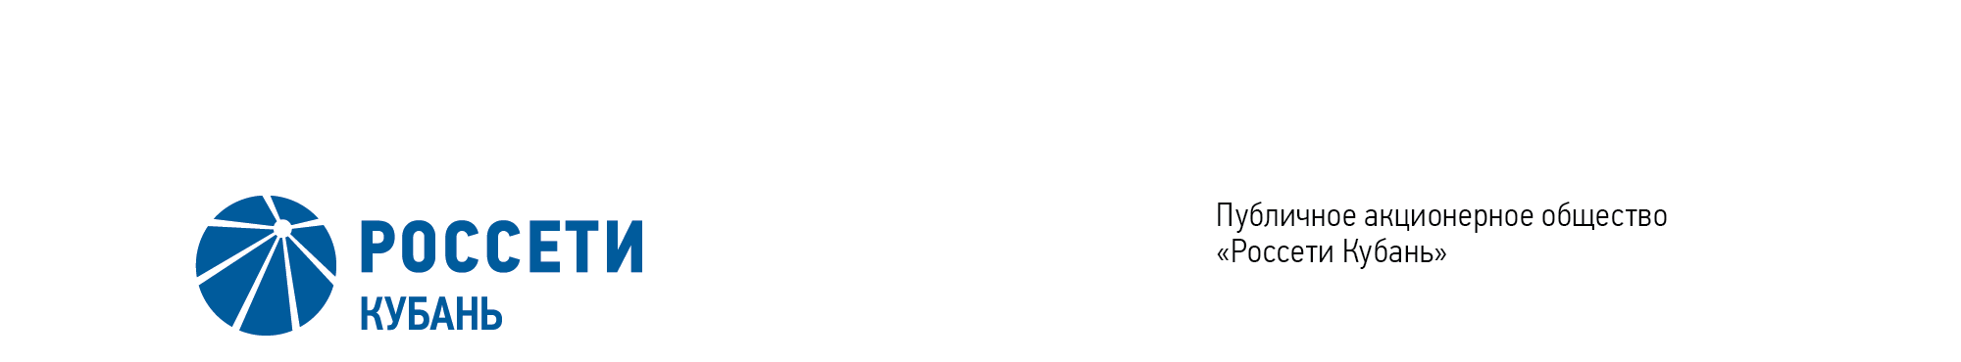
Minutes of the Meeting of the Board of Directors No. 442/2021

of the Public Joint Stock Company

Rosseti Kuban (PJSC Rosseti Kuban)
Date of Meeting | July 21, 2021
Form of Meeting: | Absentee voting (by questionnaire)
Location of summing up the voting results: | room 202, building 2, 2А Stavropolskaya Str., Krasnodar (for postage to the Corporate Secretary of PJSC Rosseti Kuban)
Date on which the minutes were drawn up: | July 23, 2021
Members of the Board of Directors: 11 persons
Members of the Board of Directors were submitted the checklists: Krainskiy D.V. (Chairman of the Board of Directors), Gladkovskiy G.K., Kazakov A.I., Molskiy A.V., Medvedev M.V., Ozhegina N.K., Prokhorov E.V., Polinov A. A., Sergeev S.V., Tikhonova M.G., Yavorskiy V.K.
Members of the Board of Directors were not submitted the checklists: None.
In accordance with the Clause 7.3 “Regulations on the Board of Directors of Public Joint Stock Company of Power Industry and Electrification of Kuban” (passed by the decision of the Annual General Meeting of Shareholders of PJSC Kubanenergo, Minutes No. 43 of May 29, 2020) at least half of the number of elected members of the Board of Directors of the Company constitutes a quorum for a meeting of the Board of Directors.
A quorum is present.

Agenda of the meeting of the Board of Directors:
1. On determination of the amount of payment for services of the Company’s auditor.

Item No. 1: On determination of the amount of payment for services of the Company’s auditor.
The following solution was offered:
To determine the amount of payment for services of the Company’s auditor to render audit services of accounting (financial) statements for 2021, that are prepared in accordance with RAS, the audit of consolidated financial statements, that are prepared in accordance with International Financial Reporting Standards (IFRS) for the year ended on December 31, 2021, amounted to 5,704,400 (five million seven hundred and four thousand four hundred) rubles 00 kopeck including VAT 20%.
Krainskiy D.V. | - | “FOR” | Prokhorov E.V. | - | “FOR”
Gladkovskiy G.K. | - | “FOR” | Sergeev S.V. | - | “FOR”
Kazakov A.I. | - | “FOR” | Ozhegina N.K. | - | “FOR”
Molskiy A.V. | - | “FOR” | Tikhonova M.G. | - | “FOR”
Medvedev M.V. | - | “FOR” | Yavorskiy V.К. | - | “FOR”
Polinov А.А. | - | “FOR”
Thus, regarding the first Agenda Item of the meeting, the resolution was adopted unanimously by the Board of Directors participating in the meeting.

Chairman of the Board of Directors D.V. Krainskiy

Corporate Secretary O.V. Russu

