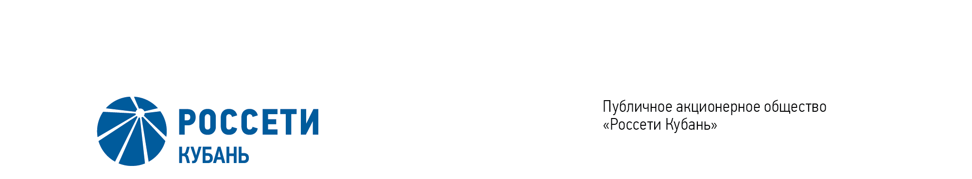
Minutes of the Meeting of the Board of Directors No. 438/2021

of the Public Joint Stock Company

Rosseti Kuban (PJSC Rosseti Kuban)
Date of Meeting | July 1, 2021
Form of Meeting: | Absentee voting (by questionnaire)
Location of summing up the voting results: | room 202, building 2, 2А Stavropolskaya Str., Krasnodar (for postage to the Corporate Secretary of PJSC Rosseti Kuban)
Date on which the minutes were drawn up: | July 1, 2021

Members of the Board of Directors: 11 persons
Members of the Board of Directors were submitted the checklists: Krainskiy D.V. (Chairman of the Board of Directors), Gladkovskiy G.K., Kazakov A.I., Molskiy A.V., Medvedev M.V., Prokhorov E.V., Sergeev S.V., Tikhonova M.G., Yavorskiy V.K.
Members of the Board of Directors were not submitted the checklists: Ozhegina N.K., Polinov A. A.
In accordance with the Clause 7.3 “Regulations on the Board of Directors of Public Joint Stock Company of Power Industry and Electrification of Kuban” (passed by the decision of the Annual General Meeting of Shareholders of PJSC Kubanenergo, Minutes No. 43 of May 29, 2020) at least half of the number of elected members of the Board of Directors of the Company constitutes a quorum for a meeting of the Board of Directors.
A quorum is present.

Agenda of the meeting of the Board of Directors:
1. On accession to the changes in the Unified Standard of Purchase of PJSC Rosseti (Regulations on purchase) passed by the decision of the Board of Directors of PJSC Rosseti.

Item No. 1: On accession to the changes in the Unified Standard of Purchase of PJSC Rosseti (Regulations on purchase) passed by the decision of the Board of Directors of PJSC Rosseti.
The following solution was offered:
To adhere to changes in the Unified Standard of Purchase of PJSC Rosseti (Regulations on purchase) passed by the decision of the Board of Directors of PJSC Rosseti of June 25, 2021 (Minutes No. 462) in accordance with the Appendix to the present resolution of the Company’s Board of Directors.
Krainskiy D.V. | - | “FOR” | Prokhorov E.V. | - | “FOR”
Gladkovskiy G.K. | - | “FOR” | Sergeev S.V. | - | “FOR”
Kazakov A.I. | - | “FOR” | Tikhonova M.G. | - | “FOR”
Molskiy A.V. | - | “FOR” | Yavorskiy V.К. | - | “FOR”
Medvedev M.V. | - | “FOR”
Thus, regarding the first Agenda Item of the meeting, the resolution was adopted unanimously by the Board of Directors participating in the meeting.

Chairman of the Board of Directors D.V. Krainskiy

Corporate Secretary O.V. Russu

