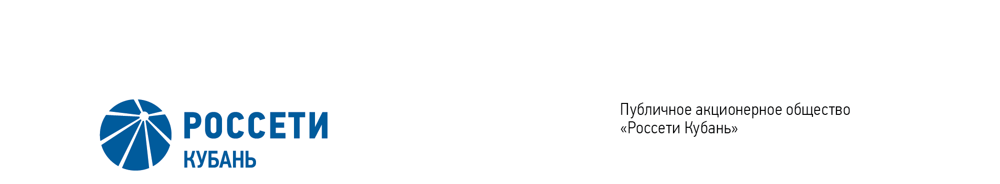
Minutes of the Meeting of the Board of Directors No. 437/2021

of the Public Joint Stock Company

Rosseti Kuban (PJSC Rosseti Kuban)
Date of Meeting | June 30, 2021
Form of Meeting: | Absentee voting (by questionnaire)
Location of summing up the voting results: | room 202, building 2, 2А Stavropolskaya Str., Krasnodar (for postage to the Corporate Secretary of PJSC Rosseti Kuban)
Date on which the minutes were drawn up: | July 1, 2021

Members of the Board of Directors: 11 persons
Members of the Board of Directors were submitted the checklists: Krainskiy D.V., Gladkovskiy G.K., Kazakov A.I., Molskiy A.V., Medvedev M.V., Ozhegina N.K., Prokhorov E.V., Sergeev S.V., Tikhonova M.G., Yavorskiy V.K.
Members of the Board of Directors were not submitted the checklists: Polinov A. A.
In accordance with the Clause 7.3 “Regulations on the Board of Directors of Public Joint Stock Company of Power Industry and Electrification of Kuban” (passed by the decision of the Annual General Meeting of Shareholders of PJSC Kubanenergo, Minutes No. 43 of May 29, 2020) at least half of the number of elected members of the Board of Directors of the Company constitutes a quorum for a meeting of the Board of Directors.
A quorum is present.

Agenda of the meeting of the Board of Directors:
- On election of the Chairman of the Company’s Board of Directors.
- On early termination of authorities and election of the members of the Management Board of the Company.
- Position of the PJSC Rosseti Kuban on Agenda Items of the Annual General Meetings of the Shareholders of subsidiaries– JSC Energetik Holiday Facility.

Item No. 1: On election of the Chairman of the Company’s Board of Directors.
The following solution was offered:
To elect as the Chairman of the Company’s Board of Directors Krainskiy Daniil Vladimirovich, the Deputy Chief Executive Officer for Legal Support of PJSC Rosseti.
Krainskiy D.V. | - | “FOR” | Prokhorov E.V. | - | “FOR”
Gladkovskiy G.K. | - | “FOR” | Sergeev S.V. | - | “FOR”
Kazakov A.I. | - | “FOR” | Ozhegina N.K. | - | “FOR”
Molskiy A.V. | - | “FOR” | Tikhonova M.G. | - | “FOR”
Medvedev M.V. | - | “FOR” | Yavorskiy V.К. | - | “FOR”
Thus, regarding the first Agenda Item of the meeting, the resolution was adopted by a majority of votes of the total number of votes of the members of the Board of Directors.

Item No. 2: On early termination of authorities and election of the members of the Management Board of the Company.
The following solution was offered:
- To remove the member of the Management Board Shchepakin Maksim Mikhailovich - the First Deputy Chief Executive Officer of PJSC Rosseti Kuban.

- To elect as the member of the Management Board of the Company Dzhabrailova Yulianna Khasanovna, the Chief of the Apparatus of PJSC Rosseti Kuban.
The results of voting:
Krainskiy D.V. | - | “FOR” | Prokhorov E.V. | - | “FOR”
Gladkovskiy G.K. | - | “FOR” | Sergeev S.V. | - | “FOR”
Kazakov A.I. | - | “FOR” | Ozhegina N.K. | - | “FOR”
Molskiy A.V. | - | “FOR” | Tikhonova M.G. | - | “FOR”
Medvedev M.V. | - | “FOR” | Yavorskiy V.К. | - | “FOR”
Thus, regarding the second Agenda Item of the meeting, the resolution was adopted unanimously by the Board of Directors participating in the meeting.

Item No. 3: Position of the PJSC Rosseti Kuban on Agenda Items of the Annual General Meetings of the Shareholders of subsidiaries– JSC Energetik Holiday Facility.
The following solution was offered:
1. To assign the representatives of PJSC Rosseti Kuban at the Annual General Meetings of the Shareholders of JSC Energetik Holiday Facility to:
1.1. On the item of the Agenda “Election of the members of the Board of Directors” to vote for adopting the following decision:
The following candidates shall be elected as the Board of Directors of JSC Energetik Holiday Facility:
1 | Kalmykova Olga Nikolaevna | HR Director of PJSC Rosseti Kuban
2 | Strelkovskaya  Natalya Mikhailovna | Head of Finance Department of PJSC Rosseti Kuban
3 | Didenko  Ekaterina Evgenevna | Head of Corporate Support Department of PJSC Rosseti Kuban
4 | Nekhaeva  Svetlana Mikhailovna | Head of the Department of Economics of PJSC Rosseti Kuban
5 | Fidyaeva  Vera Vasilevna | Head of Property Management Department of PJSC Rosseti Kuban
The results of voting:
Krainskiy D.V. | - | “FOR” | Prokhorov E.V. | - | “FOR”
Gladkovskiy G.K. | - | “FOR” | Sergeev S.V. | - | “FOR”
Kazakov A.I. | - | “FOR” | Ozhegina N.K. | - | “FOR”
Molskiy A.V. | - | “FOR” | Tikhonova M.G. | - | “FOR”
Medvedev M.V. | - | “FOR” | Yavorskiy V.К. | - | “FOR”
Thus, regarding the third Agenda Item of the meeting, the resolution was adopted unanimously by the Board of Directors participating in the meeting.

Chairman of the Board of Directors D.V. Krainskiy

Corporate Secretary O.V. Russu

