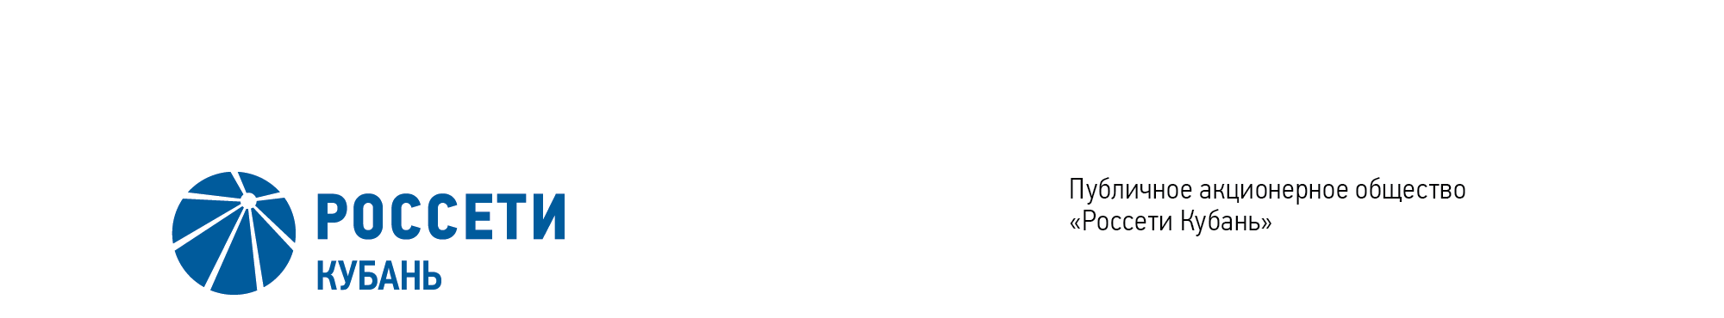
Minutes of the Meeting of the Board of Directors No. 421/2021

of the Public Joint Stock Company

Rosseti Kuban (PJSC Rosseti Kuban)
Date of Meeting | February 24, 2021
Form of Meeting: | Absentee voting (by questionnaire)
Location of summing up the voting results: | room 202, building 2, 2А Stavropolskaya Str., Krasnodar (for postage to the Corporate Secretary of PJSC Rosseti Kuban)
Date on which the minutes were drawn up: | February 24, 2021
Members of the Board of Directors: 11 persons
Members of the Board of Directors were submitted the checklists: Gavrilov A.I. (Chairman of the Board of Directors), Alyushenko I.D., Varvarin A.V., Guryanov D.L., Logatkin A.V., Medvedev M.V., Sergeev S.V., Shagina I.A., Yavorskiy V.K.
Members of the Board of Directors were not submitted the checklists: Varseev V. V., Terekhov I.A.
In accordance with the Clause 7.3 “Regulations on the Board of Directors of Public Joint Stock Company of Power Industry and Electrification of Kuban” (passed by the decision of the Annual General Meeting of Shareholders of PJSC Kubanenergo, Minutes No. 43 of May 29, 2020) at least half of the number of elected members of the Board of Directors of the Company constitutes a quorum for a meeting of the Board of Directors.
A quorum is present.

Agenda of the meeting of the Board of Directors:
- On the approval of the amendments to the Investment Programme of PJSC Rosseti Kuban for the period 2018-2022, approved by Order of the Ministry of Energy of the Russian Federation of December 1, 2017 No.21@, taking into account amendments that have been introduced by the Order of the Ministry of Energy of the Russian Federation of December 25, 2020 No. 23@.

Item No. 1: On the approval of the amendments to the Investment Programme of PJSC Rosseti Kuban for the period 2018-2022, approved by Order of the Ministry of Energy of the Russian Federation of December 1, 2017 No.21@, taking into account amendments that have been introduced by the Order of the Ministry of Energy of the Russian Federation of December 25, 2020 No. 23@.
The following solution was offered:
- To approve the draft amendments to the Investment Programme of PJSC Rosseti Kuban for the period 2018-2022, approved by Order of the Ministry of Energy of the Russian Federation of December 1, 2017 No.21@, taking into account amendments that have been introduced by the Order of the Ministry of Energy of the Russian Federation of December 25, 2020 No. 23@ in accordance with Appendix to the present resolution to the Company’s Board of Directors.
2. To assign the Chief Executive Officer (CEO) to provide:
2.1. To provide the approval of amendments to the Investment Programme of PJSC Rosseti Kuban for the period 2018-2022, approved by Order of the Ministry of Energy of the Russian Federation of December 1, 2017 No.21@, taking into account amendments that have been introduced by the Order of the Ministry of Energy of the Russian Federation of December 25, 2020 No. 23@, to the Ministry of Energy of the Russian Federation in accordance with the procedure established by the Decree of the Government of the Russian Federation of December 1, 2009 No.977 “On investment programs of electric power industry entities”.
2.2. To submit a report on the implementation of Clause 2.1 of the present resolution for consideration by the Board of Directors of the Company including the reasons for deviation of the approved investment programme from the investment project approved by the Board of Directors of the Company (in the case of deviations) within 30 working days after the approval of amendments to the Investment Programme of PJSC Rosseti Kuban for the period 2018-2022, approved by Order of the Ministry of Energy of the Russian Federation of December 1, 2017 No.21@, taking into account amendments that have been introduced by the Order of the Ministry of Energy of the Russian Federation of December 25, 2020 No. 23@, to the Ministry of Energy of the Russian Federation in accordance with the procedure established by the Decree of the Government of the Russian Federation of December 1, 2009 No.977 “On investment programs of electric power industry entities”.
The results of voting:
Gavrilov A.I. | - | “FOR” | Medvedev M.V. | - | “FOR”
Alyushenko I. D | - | “FOR” | Sergeev S.V. | - | “FOR”
Varvarin А.V. | - | “FOR” | Shagina I.A. | - | “FOR”
Guryanov D.L. | - | “FOR” | Yavorskiy V.К. | - | “FOR”
Logatkin A.V. | - | “FOR”
Thus, regarding the first Agenda Item of the meeting, the resolution was adopted unanimously by the Board of Directors participating in the meeting.

Chairman of the Board of Directors А.I. Gavrilov

Corporate Secretary O.V. Russu

