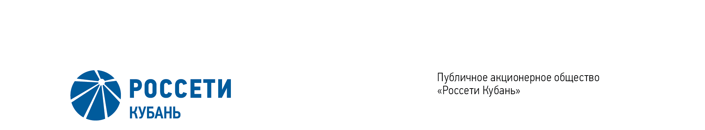
Minutes of the Meeting of the Board of Directors No. 440/2021

of the Public Joint Stock Company

Rosseti Kuban (PJSC Rosseti Kuban)
Date of Meeting | July 7, 2021
Form of Meeting: | Absentee voting (by questionnaire)
Location of summing up the voting results: | room 202, building 2, 2А Stavropolskaya Str., Krasnodar (for postage to the Corporate Secretary of PJSC Rosseti Kuban)
Date on which the minutes were drawn up: | July 9, 2021
Members of the Board of Directors: 11 persons
Members of the Board of Directors were submitted the checklists: Krainskiy D.V. (Chairman of the Board of Directors), Gladkovskiy G.K., Kazakov A.I., Molskiy A.V., Medvedev M.V., Ozhegina N.K., Prokhorov E.V., Polinov A. A., Sergeev S.V., Tikhonova M.G., Yavorskiy V.K.
Members of the Board of Directors were not submitted the checklists: None.
In accordance with the Clause 7.3 “Regulations on the Board of Directors of Public Joint Stock Company of Power Industry and Electrification of Kuban” (passed by the decision of the Annual General Meeting of Shareholders of PJSC Kubanenergo, Minutes No. 43 of May 29, 2020) at least half of the number of elected members of the Board of Directors of the Company constitutes a quorum for a meeting of the Board of Directors.
A quorum is present.

Agenda of the meeting of the Board of Directors:
- On approval of the updated version of the Regulation of PJSC Rosseti “On the uniform technological policy in the integrated power grid” as an internal document of the Company.
- On consideration of the report on implementation of the Intellectual Energy Accounting Development Program of PJSC Rosseti Kuban for 2020-2030 based on the results of 2020.
- On consideration of reports of the Committees of the Board of Directors of the Company on the work performed for 2020-2021 corporate year.

Item No. 1: On approval of the updated version of the Regulation of PJSC Rosseti “On the uniform technological policy in the integrated power grid” as an internal document of the Company.
The following solution was offered:
- To approve the updated version of the Regulation of PJSC Rosseti “On the uniform technological policy in the integrated power grid” as an internal document of the Company (Minutes No. 450 of April 2, 2021) in accordance with Appendix No.1 to the present resolution.
2. The updated version of the Regulation of PJSC Rosseti “On the uniform technological policy in the integrated power grid”, approved by the decision of the Board of Directors of PJSC Rosseti Kuban of December 21, 2019, as an internal document of the Company (Minutes of December 25, 2019) is considered to be no longer in force
The results of voting:
Krainskiy D.V. | - | “FOR” | Prokhorov E.V. | - | “FOR”
Gladkovskiy G.K. | - | “FOR” | Sergeev S.V. | - | “FOR”
Kazakov A.I. | - | “FOR” | Ozhegina N.K. | - | “FOR”
Molskiy A.V. | - | “FOR” | Tikhonova M.G. | - | “FOR”
Medvedev M.V. | - | “FOR” | Yavorskiy V.К. | - | “FOR”
Polinov А.А. | - | “FOR”
Thus, regarding the first Agenda Item of the meeting, the resolution was adopted unanimously by the Board of Directors participating in the meeting.

Item No. 2: On consideration of the report on implementation of the Intellectual Energy Accounting Development Program of PJSC Rosseti Kuban for 2020-2030 based on the results of 2020.
The following solution was offered:
Take into consideration the report on implementation of the Intellectual Energy Accounting Development Program of PJSC Rosseti Kuban for 2020-2030 based on the results of 2020 in accordance with Appendix No.2 to the present resolution of the Company’s Board of Directors.
The results of voting:
Krainskiy D.V. | - | “FOR” | Prokhorov E.V. | - | “FOR”
Gladkovskiy G.K. | - | “FOR” | Sergeev S.V. | - | “FOR”
Kazakov A.I. | - | “FOR” | Ozhegina N.K. | - | “FOR”
Molskiy A.V. | - | “FOR” | Tikhonova M.G. | - | “FOR”
Medvedev M.V. | - | “FOR” | Yavorskiy V.К. | - | “FOR”
Polinov А.А. | - | “FOR”
Thus, regarding the second Agenda Item of the meeting, the resolution was adopted unanimously by the Board of Directors participating in the meeting.

Item No. 3: On consideration of reports of the Committees of the Board of Directors of the Company on the work performed for 2020-2021 corporate year.
The following solution was offered:
Take into consideration the reports of the Committees of the Board of Directors of the Company on the work performed for 2020-2021 corporate year in accordance with Appendices 3-7 to the present resolution of the Company’s Board of Directors.
The results of voting:
Krainskiy D.V. | - | “FOR” | Prokhorov E.V. | - | “FOR”
Gladkovskiy G.K. | - | “FOR” | Sergeev S.V. | - | “FOR”
Kazakov A.I. | - | “FOR” | Ozhegina N.K. | - | “FOR”
Molskiy A.V. | - | “FOR” | Tikhonova M.G. | - | “FOR”
Medvedev M.V. | - | “FOR” | Yavorskiy V.К. | - | “FOR”
Polinov А.А. | - | “FOR”
Thus, regarding the third Agenda Item of the meeting, the resolution was adopted unanimously by the Board of Directors participating in the meeting.

Chairman of the Board of Directors D.V. Krainskiy

Corporate Secretary O.V. Russu

